Mock Test – Part 2 (5 points ICE) Name________________________________

Part 1: Simple questions.

1. 5. Which of the following is NOT an essential characteristic of cloud computing as defined by NIST?

a. On-demand self-service b. Resource pooling c. Resource collaboration

d. Rapid elasticity e. Measured service

1. What is MapReduce as introduced by Google?

(a) A programming model for processing large data

(b) A new computer architecture for support of cloud computing

(c) A cloud service provided by Google

(d) none of above

1. A geographically distributed network of proxy servers as well as data centers that provides high availability and high performance by distributing the service spatially relative to end-users. This network is called:

(a) SAN (Storage area network)

(b) CDN (content delivery/distribution network)

(c) NAS (network attached storage)

(d) None of above

1. Which of the following is True in terms of VMM?
2. VMM stands for Virtual Machine Memory.
3. A hypervisor is one type of VMMs.
4. VMM virtualizes the memory only not the CPU.
5. None of above is true.
6. Given the image below, identify the type of virtualization used in each graph.

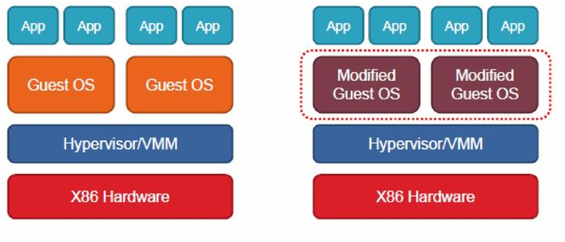

Part 2: Short answers.

1. Assume you are asked to deploy a cloud solution on Amazon EC2 or similar cloud services, describe the key steps (i.e. specific actions) you’d take from scratch to deploy such a cloud solution. (You may assume one kind of cloud solution such as deploying a web service etc.)

1. One of the challenges faced by cloud computing is the security. Describe a security breach case happened on AWS. On which cloud service it happened? What was the problem? Any solution you’d suggest to prevent future occurrence of similar problems?